jS notes
topic | types | information |  |  | apply
Variable
Deta type | - Var  - Let  - const | - its old method that is used we can make another variable with same name and using this keyword again  - let is advance we use is as we use in java any deta type  - const use for constant variable
Extra comparison operator
- == operator |  | - Its compare only value not type
- === |  | - Its compare only value and type both
- != |  | - Its check only value
- !== |  | - Its compare only value and type both
“For in” and “ For of “ loop
For of |  | In array its take index value and in object ita take object key value
For in |  | In array its take index number and in object its take object key name
Custom Attribute
intro |  | Ham apna khud ka attribue bhi bana saktee id, class ke ilawa |  |  | data-attributeName=”value”  data keyword zarorii hota hay js main hum e.target.getAttribute se iss ko access kr saktee hay
Built in function of array
These function don’t change original array
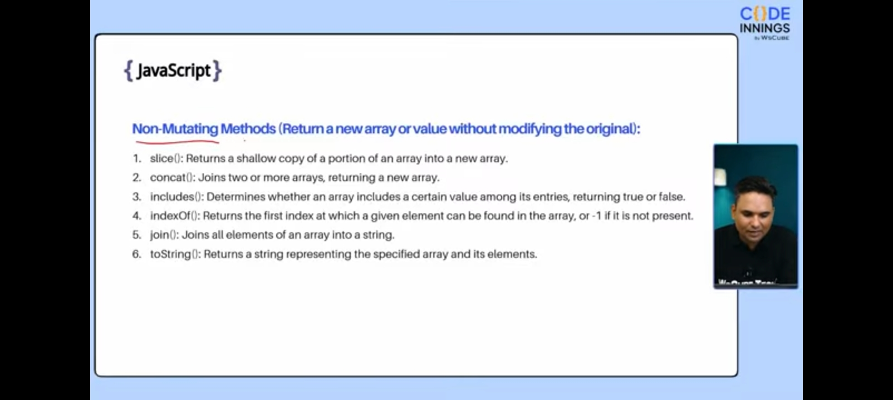
These function change original array
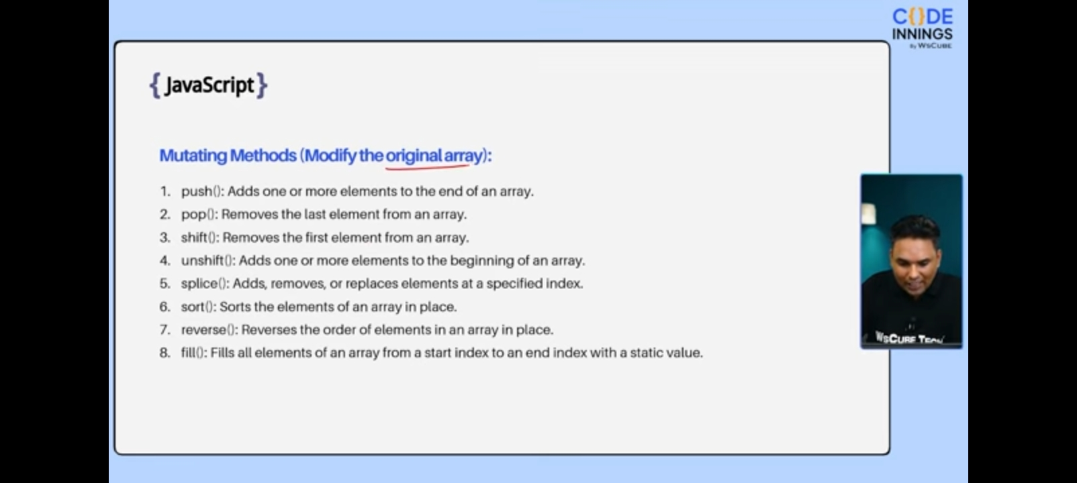
Call back function
Use of call back function |  | Agar hamare pass multiple function ho tu ham aik call back function bana saktee hay jis main function ka name as a parameter de saktee hay |  |  | Function sum(a,b){  Return a+b;  }  Function sub(a,b){  Return a-b;  }  Function calculation(a,b,callBack){  callBack(a,b)}
Anonymous Function
Intro |  | Ye function name ke baghair hota hay is function ko aik variable name e zaryee call kya jata hay |  |  | const name=function(){  }  //For calling  name();
Arrow Function |  | - Ye bhi aik anonmyious function hay  - Is main function keyword likhne ki ned nhi hotii hy  - Agar aik hi variable ho tu use parameter main likhne ki need nhi hotii hay  - Agar curly bracket na lagii ho aur code ki aik hi line ho tu return keyword use nhi kya jata |  |  | Const  /*no parameter no return keywords*/  value=x=>x*x  //for other purpose  Const value=(a,b,c)=>{  }
Object
Object |  | There are two parts  - Key  - value |  |  | Let user={  userEmail:”uamk@gmail”,  phone:03468322435,  }
For call |  | Ther are two method gor getting value in object  - objectName.key  - objectName[key] |  |  | user.userEmail  user[‘userEmail’]
For add/update |  | - objectName.key=value;
Destructing |  | Its used for take key of object and use as a variable |  |  | let {userEmail,phone}=user  /*if we want take only phone*/  let {phone}=user
Rename object key |  | Is ko object key ka name change karne kelye use kya jataa hay |  |  | Let {phone:myPhone}=user  /*now its variable name is myPhone*/
Rest operator |  | Ye us key ke ilawa jo as variable lya gya hay bakii all keys value nikal ke de de ga |  |  | let  {userEmail,…all value}=user
Nested destructing
Array destructing
Object destructing  - is main key name dena parta hay jo ke baad main as a variable kam arta hay  - koi bhi key name likh saktee hay chaye jis position pe para ho  - key dene kelye curly barackets use hotii hay |  |  | Array destructing  - is main key nhi hotii koi bhi name rakh saktee hay asvariable use karnee keyle  - ye array ki sequence ke sath chalta hay jb ham pehla variable name pass kartee hay wo pehla index ki value deta hay comma laga kr second index agar hamee third index ki value chahyee tu pehle 2 commas laganee paree us ke baad vaiable ka name dena paree ga  - variable name denee kelye barii brackets laganii partii hay
Deep copy and cello copy
difference |  | Deep copy main jab ham original array ko copy kartee hay tu jo jo changing ham copy array main kartee hay wo changing original array main bhi hota hay |  | Cello copy main aisa nhi hota changing in copy array original array pe effected nhi hotii | //deep copy  Let arr=[12,3,23,4,3,53]  Let copy=arr;  /*agar koi value copy main push kre ge tu arr main bhi ho gii*/  //cello copy  Let copy=[…arr]
Array higher order functions
- map
- filter
- reduce
- find
- for each
Map
intro |  | - Ye new array return karta hay har index pr changing kartne kelye use hota hay  - Callback function zarorii hay  - Parameter main first variable array ki value aur second array index return karta hay  - Ye hamsha copy array ka size original array ka qual hta hay |  |  | Let newArray=  array.map((value=>{  return value+5  })
Filter
Intro |  | - Ye bhi map ki tarah hay magar ye us waqt use hota hay jab hamee specific condition follow karne walee indexs chaye hotee hay  - Is ka size equal bhi ho sakta hay less bhi aur khalii bhi |  |  | Let newArray=  array.filter((value=>{  if(value>50)  return value;  })
Reduce
intro |  | - Ye hamesha aik single value return karta hay  - Is main pehla parameter calculation wali value hotii hay aur second array index value |  |  | Let newArray=  array.reduce((sum,value)  =>  sum+value,0  )
Find
intro |  | Ye filter ki tarah hay magar value sirf aik hi return kre ga jo pehle milee gii |  |  | Let newArray=  array.find((value=>{  if(value>50)  return value;  })
ForEach
intro |  | Ye for of loop ki tarah value print karne kelye use hota hay
DOM(document object model)
Selected element | - By Id  - Querysele-ctor  querySele-ctorAll  form ke anda name arrtribute se value li jatii hay | - Agar hamee html ki kisi atribute ko access karna hay tu ye use kya jata hay  - byId id se call karne kelye use hota hay  - queryselector se ham tag, call,id ko call kr sakte hay magar ye sirf pehle reltive cheese ko target karta hau agar sab realative chesse target karna hay tu querySelectorAll lagaya jata hay |  |  | - By id  document.getEle-mentById(“idNa-me)  - by querySelector  document.query-Selector(“.class”)  - by querySelectorAll  ye array ki sorat main element deta hay
Event
 | Event name | Working porpuse
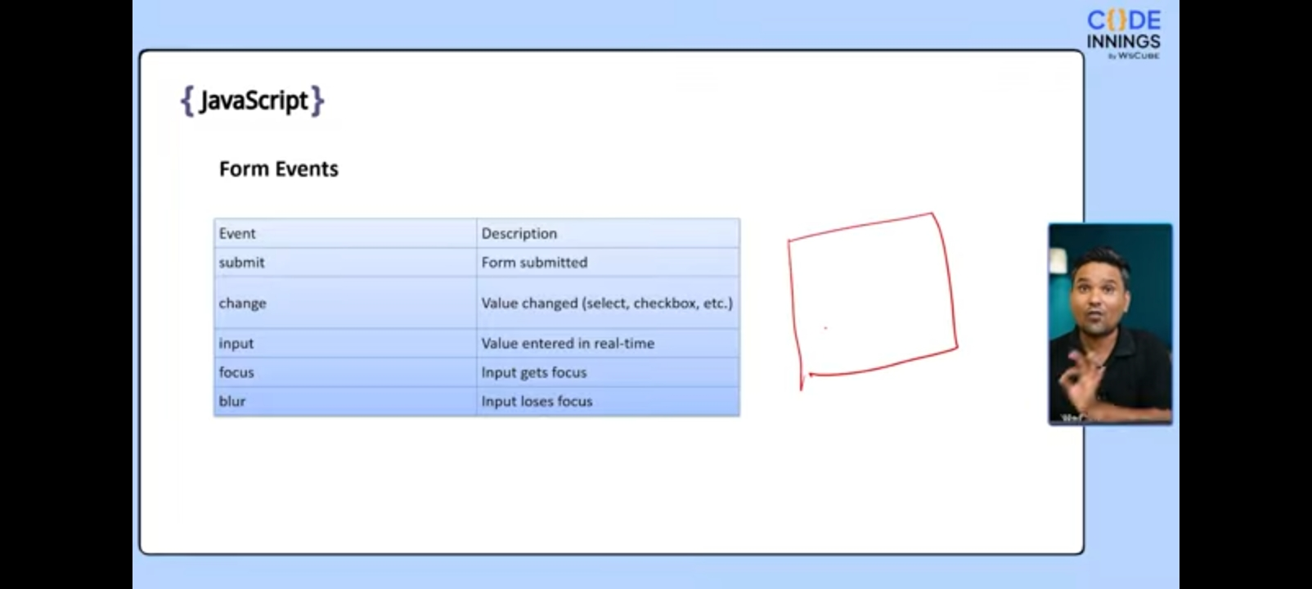
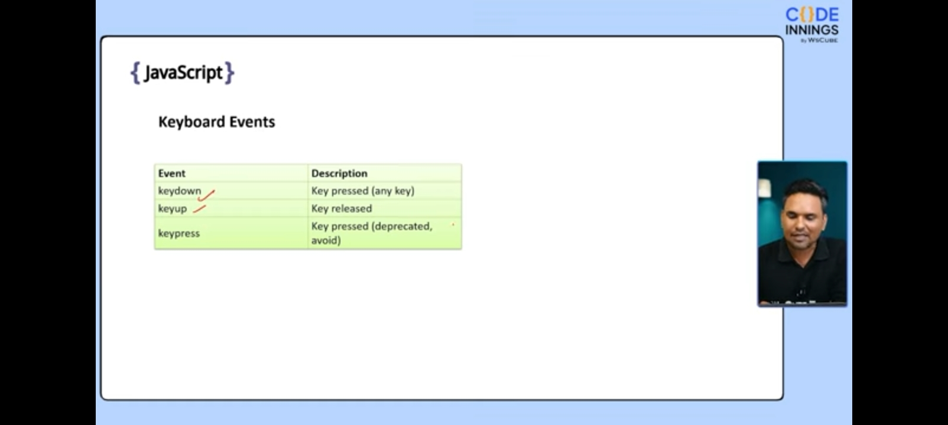
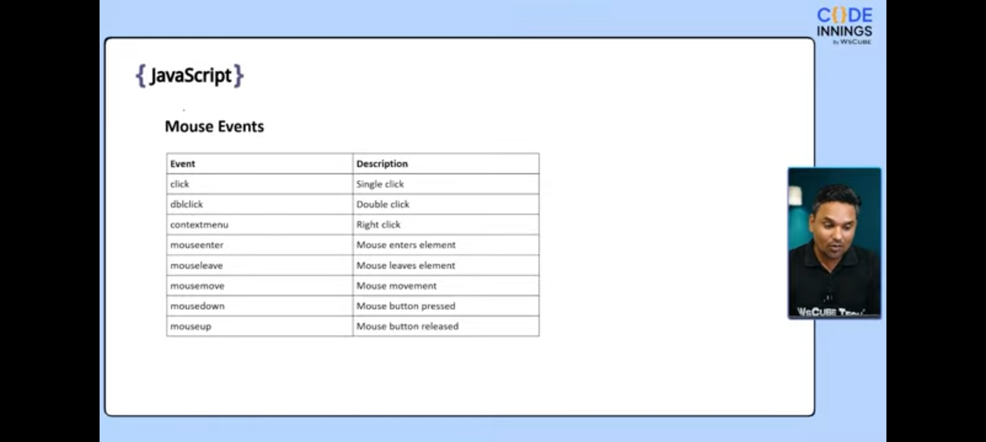
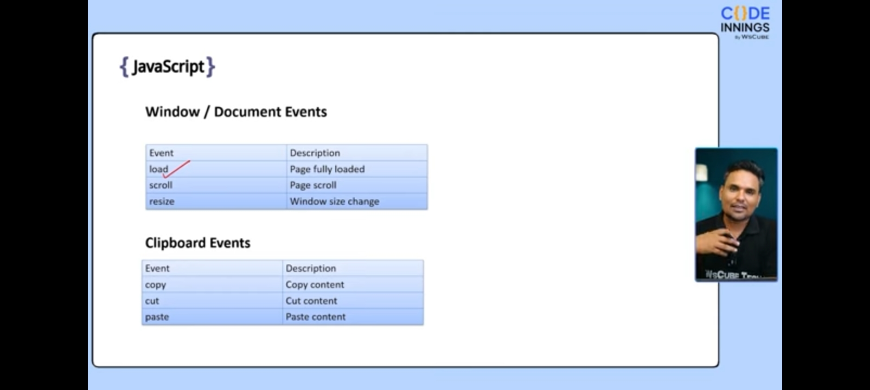
intro |  | Ham function bana kr koi kam kr saktee hay for example deta change karna koi khas kam karna |  |  | Name.addEventLIstener(“eventName”,()=>{  stracture  })
Add/remove/toggle any class
propertyNames | classList is reserve keyword | Kisii class ko html ke zarye add karne kelye use hota hay remove karne kelye ya agar ham chahte hay ke aik baar click karnee se class ki css apply ho jay aur dubara click karne pr remove ho jay gii |  |  | ButtonName.addevent-Listener(“eventName”,()=>{  Jaha pr class laganii hay.classList.property-Name(“className”  }
- Add  - Remove  - Toggel | classList is reserve keyword
Event object
intro |  | Ye event ke related sarii information deta hay |  |  | Listener(“eventName”,(e)=>{  Jaha pr class laganii hay.classList.property-Name(“className”  }  /*e yaha pe as object kam kr raha hay jo callbake main parameter dya jata ay*/
Main keys | - .type  - .target  - currentTarge  - clientX  - clientY | - Type event ki type ke baree main batai ga  - Target jaha pe event hoya hay us ke baree main batai ga  - currentTarget Jo ham ne target kya  - clientX x axis pe bata hay ke kitne px pr click hoya hay  - clientY y axis ke px batata hay
Event deligation
into |  | Agar parent ko koi event dya jay to child ko bhi event mil jata hay
Main keys | e.target.tagName | Ye tag name return karta hay magar capitilize main
Parent bubbling | e.stopPropagation | Kisi child pr agar chahte hay ke parent wala kam na kre tab use hota hay
DOM traversing
intro |  | Is ka matlab hay ke aik div se us ke parent ya child ya sibling tak jana
.children |  | Ye child ko html collection main return kr deta hay |  |  | Let prElement=document.  querySelector(“.main”)  console.log(prElement.  Children
.firstChild
.lastChild
.nextElementSibling |  | Ye agar space bhi si gi ho gii tu wo bhi rturn kre ga
. previousElementSibling |  | Ye agar space bhi si gi ho gii tu wo bhi rturn kre ga
.childNodes |  | Ye agar space bhi si gi ho gii tu wo bhi rturn kre ga
.closest |  | Ye upward chalta hay magar is main tag ka name batana parta hay ke kon sa block chayee
.parentNode
Submit event
Form submit |  | Jab bhi form pr submit button pr click kya jata hay ye refresh hota hay
e.preventDefault |  | Ye use hota hay kisii event ko cancel karne kelye
setTimeout
intro |  | Ye batata hay koi kam kitne time ke baad ho |  |  | Is main hum time ms main dete hay  First method  setTimeout(()=>{  function  },time)  Second method  Let func=()=>{  }  setTimeout(func,time)
setInterval
intro |  | Ye batata hay ke aik kam kitnee baar honaa chayee |  |  | Same as setTimeout bs keyword change ho jata hay
Date
It’s a built in object |  | Let name=new Date()
Function of date
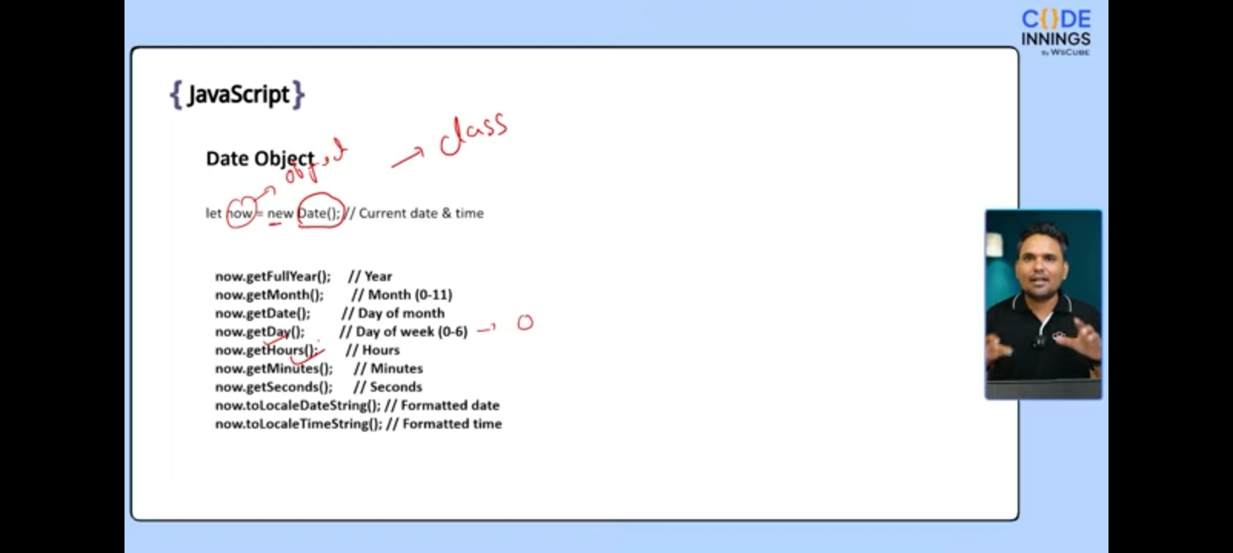

Asynchrouous programming |  | Is main task wait nhi karta agar aik task ko time lagna ho tu agla pehle chal jata hay
Synchrouous programming |  | Is main task orderwise ho gii
Common async operation |  | - API calls  - setTimeout  - file i/o  - detaBase queries
Callback hell
into |  | Agar ham chahte hay ke async ko sync sequence main chalai tu ham nested setTimeout ke zarye solve ho |  |  | Pehle bahir wala function chalee ga phir us ke andar wala phir isi sequence ke sath
promises
intro | Is main teen chesee hotii hay  - pending  - fulfilled  - rejected | Pehle parameter hamesha fulfilled ko control karta hay  Then and catch use hote vlaue lene kelye ya promise ko ontrol karne kelye  catch for fulfilled  Catch for rejected |  |  | Let m=new promise((resolve,reject)=>{  })  m.then((value)=>{  console.log(value)  })
Async/await |  | Jab ham kisi function ke zarye function ke andr kisi promises access kr rahee ho tu ye keyword use ho gee  Asyc batata hay ke async ko control karna hay await batata hay ke wait karna hay hab tak task ho na jay |  |  | Let work=(subject)=>{  Return value=new promise((resolve,reject)=>{  Resolve(`${subject} comleted`)  })  Let done=async ()=>{  Let task1=await Work(“English”)  }  Done()
Promise.all |  | Ye func ke andar all promises ko check karta hay agar aik bhi promise reject ho gya tu nhi chalee ga
Local storage
intro |  | - Key aur value ki sorat main deta store kya ja sakta hay  - No expairy date
function | 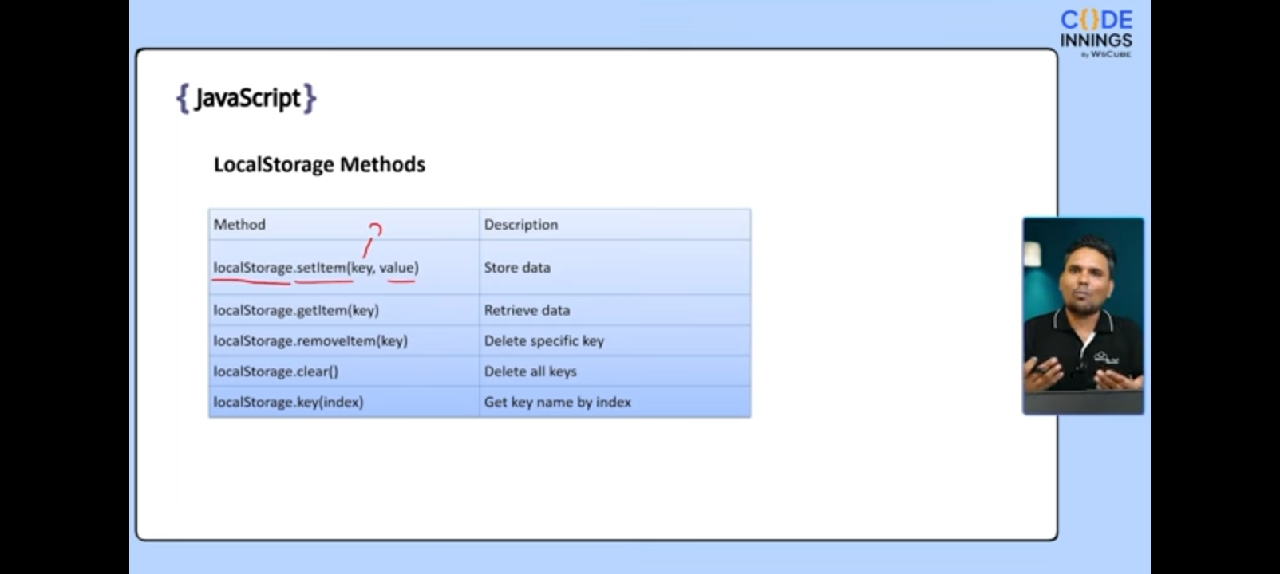
store object in localStorage |  | Object ko localStorage main store karne kelye JSON.stringify(objectName) use hota hay |  |  | Let user={  Name:”Awais”,  }  localStorage.setItem(JSON.stringify(“user”)
getting object in localStorage |  | Object ko localStorage se call karne kelye JSON.parse(localStorage.getItem(“user”))  Use hota hay |  |  | Let value=JSON.parse(LocalStorage.getItem(“user”))
Fetc API
intro |  | Fetch hamesha promise return karta hay  Fetch ke element ko get karne kelye json use hota hay |  |  | Let func=async ()=>{  Let deta=await fetch(“url”);  Let myDeta=await deta.json();  Console.log(myDeta)  }  Func()
Module
Intro/export |  | Ham aik file main function bana kr us ko export kar sakte hya  Jis file main use karna ho us main import kr saktee hay |  |  | 1st method  Export let func=()=>{  }  2nd method  Export {function1,function2}
import |  | Ham export functions ko impoert kr sakte hay kisi bhi file main |  |  | Agar usi folder main ho  Import { function1,function2} from “./file name

